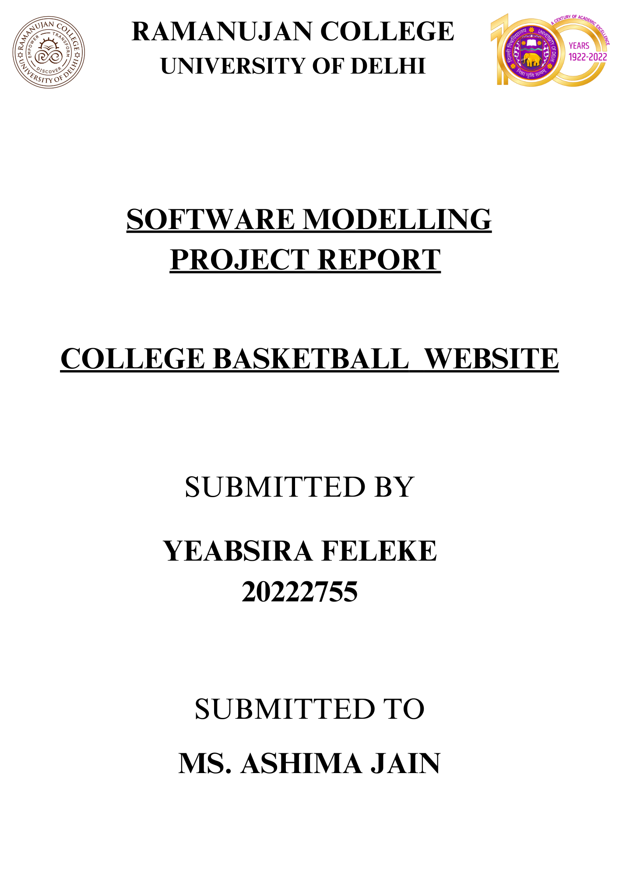

**College Basketball Team Front End Web Page Project Report**

**Abstract**

The College Basketball Team Front End Web Page project - make a few lines - FE is the UI interface which users can interact with. aimed to design and develop an interactive online platform for the college basketball team to engage with fans, provide updates, and showcase team information. This report presents a comprehensive overview of the project, detailing its background, design, implementation, results, and recommendations. The project utilized a combination of PHP - functionality, Cascading Style Sheets (CSS) - for the designs, Hyper Text Markup Language (HTML) - for the project skeleton, and JavaScript (JS) - Functionality. technologies to achieve its objectives, with a focus on user engagement and usability.

**Project Objectives**

The primary objective of the project was to create a dynamic and user-friendly web page that provides comprehensive information about game schedules, player profiles, and news updates, while incorporating real-time score updates during live games.

**Approach**

The project adopted a systematic approach, starting from requirements analysis and design to implementation, testing, and deployment. The design phase involved creating wire frames and user interface mock up, while the implementation phase focused on translating the design specifications into functional code.

**Achievements**

Through the utilization of PHP, CSS, HTML, and JavaScript technologies, the project achieved its objectives by focusing on user engagement, usability, and scalability. Key achievements include the successful implementation of features such as a dynamic game schedule, player profiles with statistics, news updates, and live score updates.

**Conclusion**

Overall, the project demonstrated significant progress towards enhancing the online presence of the college basketball team and providing an engaging experience for fans and stakeholders. The successful completion of the project reflects the dedication and collaboration of the project team in meeting the project objectives and delivering a high-quality web platform.

**Table of Contents**

**1. Introduction**

**2. Project Background**

**2.1 Problem Statement & process model**

**2.2 Objectives**

**2.3 Scope**

**3. Requirement Analysis**

**3.1 Creating a Data Flow**

**3.2 Data Dictionary**

**3.3 Use Cases**

**4. Design**

**4.1 User Interface Design**

**4.2 System Architecture**

**5. Implementation**

**5.1 Technologies Used**

**5.2 Development Environment Setup**

**5.3 Coding Practices**

**6. Testing and Quality Assurance**

**6.1 Test Plan**

**6.2 Test Cases**

**6.3 Quality Assurance Process**

**7. Project Management**

**7.1 Computing FP**

**7.2 Effort Estimation**

**7.3 Schedule**

**7.4 Risk Table**

**7.5 Timeline Chart**

**8. Results and Analysis**

**8.1 System Functionality**

**8.2 User Feedback**

**8.3 Performance Metrics**

**9. Discussion**

**9.1 Challenges Faced**

**9.2 Lessons Learned**

**10. Conclusion**

**11. Future Work**

**12. References**

Introduction

The College Basketball Team Front End Web Page project aimed to enhance the online presence of the college basketball team by providing a dynamic and user-friendly web platform. The web page serves as a central hub for fans, players, and stakeholders to access team information, game schedules, player profiles, and news updates. The project leveraged modern web development technologies to create an engaging user experience while ensuring scalability and maintainability.

1. **Project Background**:

The basketball team web page project aims to create a comprehensive online platform for a college basketball team, providing fans, players, and staff with access to essential information, updates, and resources. With the increasing importance of digital platforms in sports engagement and management, the project seeks to leverage modern web technologies to enhance the team's online presence and communication channels.

The background of the project stems from the need to centralize information related to the college basketball team, including game schedules, player profiles, news updates, and live scores. Traditionally, such information might be scattered across various sources, making it challenging for fans and stakeholders to stay informed. Therefore, the development of a dedicated web page serves to consolidate these resources into a single, user-friendly interface

**2.1 Problem Statement:**

The college basketball team lacks an effective digital platform to engage with fans, manage team information, and provide updates on player performance and game schedules. Currently, there is a lack of centralized access to player profiles, game schedules, and news updates, leading to fragmented communication channels and limited fan engagement opportunities.

**Issues**

1. **Limited Fan Engagement:**

- The absence of a dedicated platform restricts opportunities for fans to interact with the team, participate in discussions, and stay updated on team activities and achievements.

**2. Inefficient Information Management:**

- Player profiles, game schedules, and news updates are dispersed across various offline and online channels, making it difficult for fans and team members to access timely and accurate information.

**3. Inconsistent Communication:**

- Communication between the team, fans, and stakeholders is inconsistent and lacks a unified platform for sharing news, updates, and announcements.

**4. Lack of Player Visibility:**

- Fans have limited access to detailed player profiles, statistics, and performance data, hindering their ability to engage with individual players and track their progress over time.

**Impact:**

**Diminished Fan Experience**: The lack of a comprehensive digital platform undermines the fan experience and reduces opportunities for fan involvement and support.

**Disorganized Team Management**:Without a centralized system for managing team information and communication, the coaching staff and administrators face challenges in coordinating team activities and engaging with fans effectively.

**Solution:**

Developing a robust college basketball team website will address these issues by providing a centralized platform for fans, players, coaches, and administrators to interact, access information, and stay connected. The website will feature player profiles, game schedules, news updates, and fan engagement tools to enhance the overall fan experience and streamline team management processes.

By implementing a comprehensive digital solution, the college basketball team can foster greater fan engagement, improve communication channels, and enhance the visibility of players and team activities, ultimately strengthening the team's presence within the community and beyond.

**Process Model**

For the development of the college basketball team website, an iterative and incremental process model such as the Agile methodology would be suitable. This approach emphasizes collaboration, flexibility, and delivering working software in short iterations. Here's how the Agile process model could be adapted for this project:

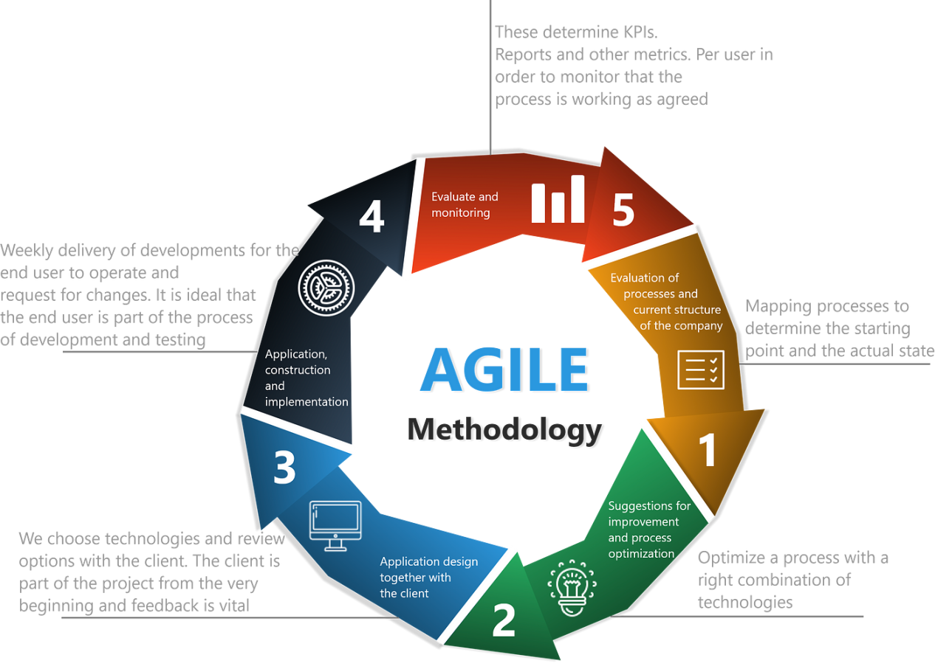

***1. Project Initiation:***

- Define project objectives, scope, and requirements in collaboration with another people.

- Formulate the project team comprising developers, designers, testers, and stakeholders.

***2. Sprint Planning:***

- Break down the project scope into manageable user stories or tasks.

- Prioritize user stories based on value and dependencies.

- Plan the first sprint, including the selection of user stories to be implemented.

***3. Sprint Execution:***

- Develop and implement features according to the selected user stories.

- Conduct daily stand-up meetings to track progress, discuss impediments, and plan for the day.

- Collaborate closely with stakeholders to gather feedback and make necessary adjustments.

***4. Sprint Review:***

- Demonstrate the completed features to stakeholders at the end of each sprint.

- Gather feedback and review the sprint's accomplishments against the initial objectives.

- Discuss any changes or updates required for upcoming sprints based on stakeholder input.

***5. Sprint Retrospective:***

- Reflect on the sprint's successes and areas for improvement.

- Identify lessons learned and actions to enhance team performance and productivity.

- Adjust processes and practices as necessary to optimize efficiency and quality.

***6. Iterative Development:***

- Repeat the sprint cycle iteratively, with each sprint focusing on delivering additional features or enhancements.

- Prioritize user stories based on stakeholder feedback, evolving requirements, and project goals.

- Continuously refine and improve the product based on user feedback and changing needs.

***7. Incremental Delivery:***

- Deliver working increments of the basketball team website at the end of each sprint.

- Incrementally add features and functionalities to the website, providing value to stakeholders with each iteration.

- Ensure that each increment is tested thoroughly to maintain quality and usability.

***8. Continuous Integration and Deployment:***

- Integrate new features and changes into the main codebase frequently.

- Automate testing and deployment processes to streamline the delivery pipeline.

- Deploy updates to the production environment regularly, ensuring that stakeholders have access to the latest features and improvements.

By adopting an Agile process model, the development team can adapt to changing requirements, incorporate feedback from stakeholders, and deliver a high-quality basketball team website that meets the needs of fans, players, coaches, and administrators. This iterative and collaborative approach promotes transparency, flexibility, and continuous improvement throughout the project lifecycle.

2.2 **Objectives:**

* Develop a user-friendly web page for the college basketball team.
* Provide comprehensive information about game schedules, player profiles, and news updates.
* Implement real-time score updates during live games.
* Ensure compatibility with various responsive devices and browsers.

2.3 **Scope:**

The scope of the project encompasses the comprehensive creation of a dynamic and interactive web presence for the college basketball team. This involves not only the design and development of the web page but also rigorous testing procedures to ensure functionality and user satisfaction. Key features will include a dynamic game schedule, where users can view upcoming matches, past results, and any changes to the schedule in real-time. Player profiles will be rich with statistics, providing fans and stakeholders with insights into individual player performance and team dynamics.

Furthermore, the web page will serve as a hub for news updates related to the team, including announcements, press releases, and interviews. This will keep fans engaged and informed about the latest developments within the team. Additionally, live score updates during games will provide an immersive experience for users, allowing them to follow the action as it unfolds in real-time.

Moreover, the web page will prioritize accessibility and responsiveness, ensuring that it can be seamlessly accessed and navigated across a variety of devices and screen sizes. This inclusivity will enhance the user experience, allowing fans to engage with the team's content anytime, anywhere. Overall, the project aims to create a vibrant and engaging online platform that fosters connection and enthusiasm among fans, players, and supporters of the college basketball team.3. Literature Review:

A review of existing literature on web development methodologies, user interface design principles, and best practices in sports team websites informed the project's approach and decision-making process. Key insights from relevant studies were incorporated into the project's design and implementation strategies.

Requirements Analysis:

**Functional Requirements**

User Authentication and Authorization:

* Users should be able to register, log in, and manage their profiles.
* Administrators should have additional privileges to manage player profiles, game schedules, and news updates.

Player Profiles:

* Display detailed profiles for each player, including personal information, statistics, and photos.
* Allow administrators to update player profiles and track player performance over time.

Game Schedule Management:

* Provide a comprehensive schedule of upcoming games, including dates, times, locations, and opponents.
* Allow administrators to add, edit, and delete game entries and update game details as needed.

News and Updates:

* Display news articles, announcements, and updates related to the basketball team.
* Allow administrators to publish news articles, upload photos, and share team updates with fans.

Fan Engagement Features:

* Include interactive features such as polls, surveys, and forums to engage fans and gather feedback.
* Integrate social media sharing options to enable fans to share content with their networks.

2. Non-Functional Requirements:

Performance:

* The website should load quickly and handle high traffic volumes during peak times (e.g., game days).
* Response times for user interactions should be fast to ensure a smooth user experience.

Security:

* Implement robust security measures to protect user data, including encryption of sensitive information and secure authentication mechanisms.
* Regularly update software components and apply security patches to mitigate vulnerabilities.

Scalability:

* Design the website to scale seamlessly as the user base grows and additional features are added.
* Ensure that the underlying infrastructure can handle increased load and traffic without performance degradation.

**Creating a Data Flow Diagram**

The data flow diagram depicts the flow of information within the college basketball team website. It illustrates how data moves between external entities, processes, and data stores. Here's a simplified example:

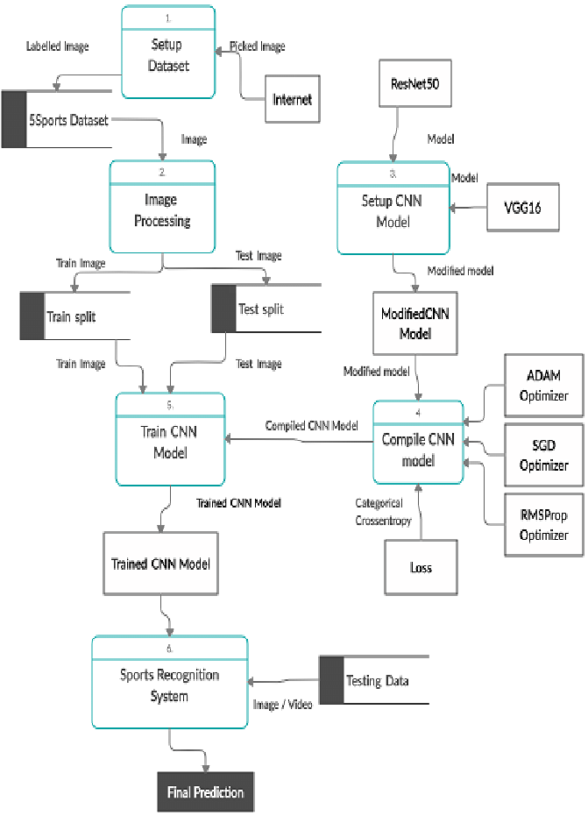

**Data Dictionary**

A data dictionary defines the structure and attributes of data entities used in the basketball team website. It provides a standardized reference for understanding and managing data. Here's an example data dictionary:

***Player Profiles:***

**Attributes**: PlayerID, Name, Position, Height, Weight, Statistics, PhotoURL

***Game Schedule:***

**Attributes**: GameID, Date, Time, Location, Opponent, Result

***News Articles:***

**Attributes**: ArticleID, Title, Content, Author, PublicationDate

**Use Cases**

Use cases describe specific interactions between users and the basketball team website. They outline the steps required to accomplish tasks and define the system's behavior from the user's perspective. Here are some example use :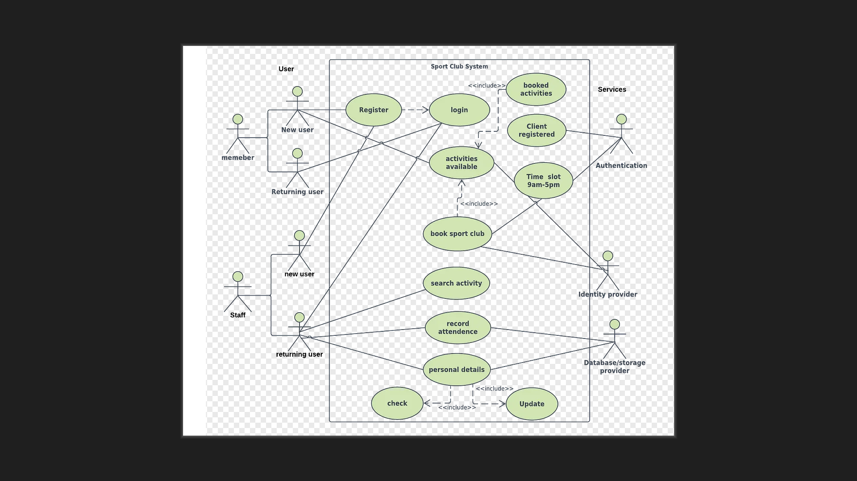

**View Player Profile:**

**Actor: User**

**Steps**:

1. User selects a player from the list of player profiles.
2. System retrieves and displays the selected player's profile information.

**Update Game Schedule:**

**Actor: Administrator**

**Steps:**

1. Administrator logs in to the system and navigates to the game schedule management section.
2. Administrator selects a game entry to update and modifies the game details as needed.
3. System saves the changes and updates the game schedule accordingly.

Design

5.1 User Interface Design:

The user interface design prioritized simplicity, clarity, and ease of navigation. Intuitive layouts, clear typography, fonts, and visually appealing graphics were employed to enhance the user experience.

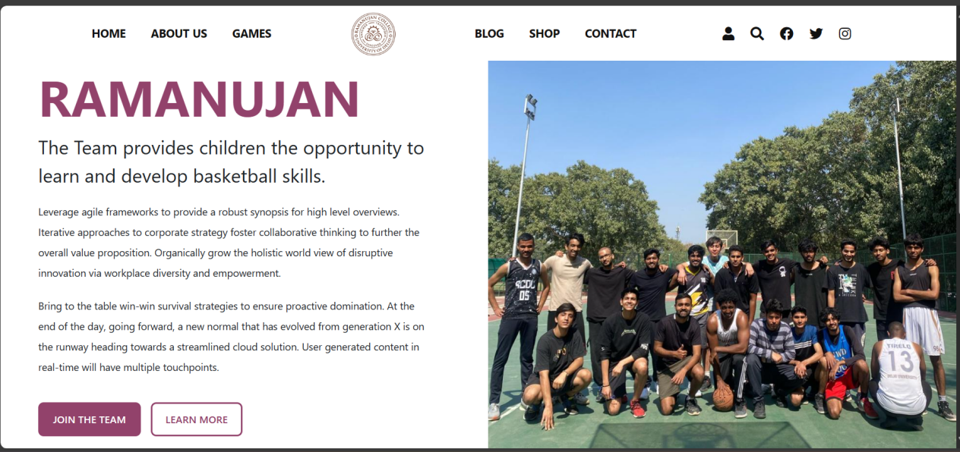

5.3 System Architecture:

The system architecture adopted a layered approach, with separate components for the presentation layer, business logic layer, and data access layer. This modular design facilitated code reuse, maintainability, and scalability.

6. Implementation:

During the implementation phase, the team followed a structured approach to translate the design specifications into functional code for the college basketball team front web page. Here's a more detailed explanation of how each technology was utilized.

6.1 Technologies Used:

* PHP: Server-side scripting language for dynamic content generation.
* CSS: Styling language for enhancing the presentation of web pages.
* HTML: Markup language for creating the structure of web pages.
* JavaScript: Client-side scripting language for interactivity and dynamic behavior.

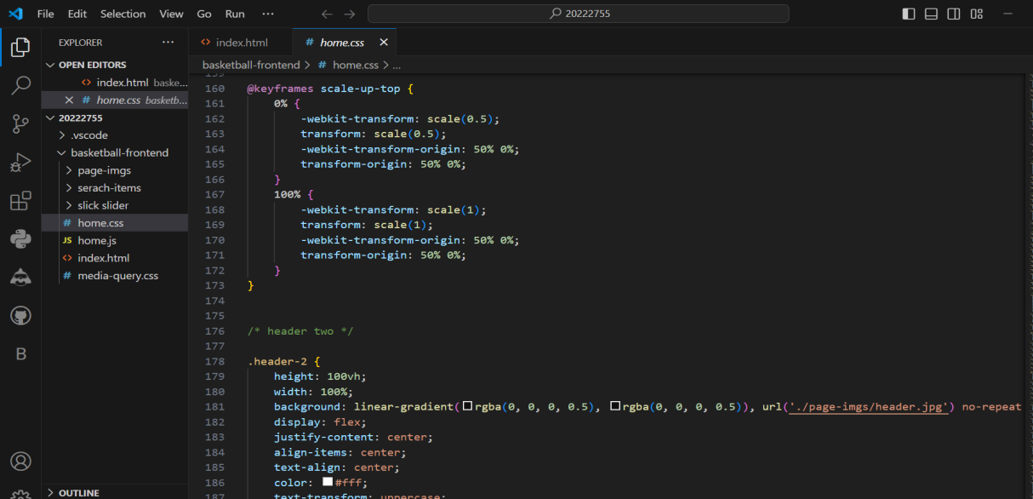

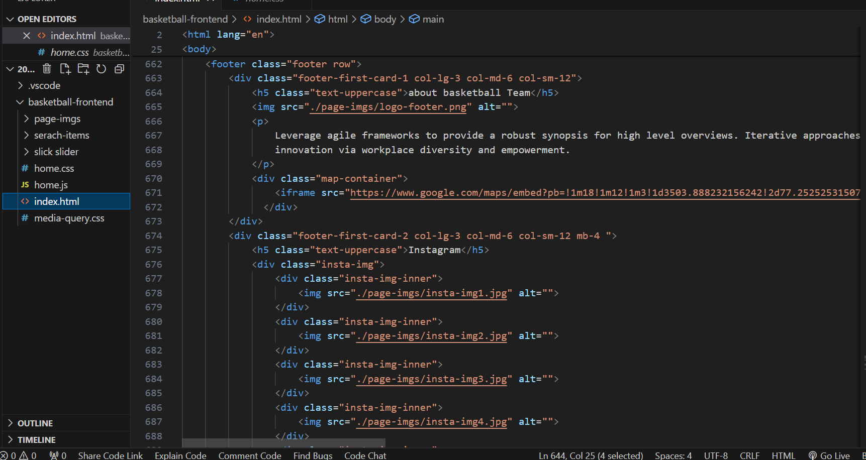

6.2 Development Environment Setup:

The project team utilized development tools such as VS code editor, version control systems (e.g., Git), and local web servers (can be hosted on free servers like heroku, netlify so I can share links with anyone) to facilitate collaborative development and testing.

6.3 Coding Practices:

Coding standards and best practices were followed to ensure consistency, readability, resusabiltiy - (for shared functions or something) and maintainability of the codebase. Code reviews and peer feedback helped identify and address potential issues early in the development process.

7. Testing and Quality Assurance: Final testing - Once it is all reviewed by peers and myself. Good to be hosted

7.1 Test Plan:

A comprehensive test plan was developed to cover functional, performance, security, and usability testing aspects of the web page. Test cases were created to validate each feature and functionality against its requirements.

7.2 Test Cases:

Test cases were executed systematically to verify the correctness and robustness of the web page. Automated testing tools and manual testing procedures were employed to identify and address any defects or vulnerabilities.

7.3 Quality Assurance Process:

* Throughout the development process, QA measures were implemented to maintain high-quality standards.
* Code reviews were conducted to identify and address any code issues, ensuring code quality and maintainability.
* Continuous integration and automated testing processes were employed to streamline testing and ensure early detection of defects.

Overall, quality assurance processes, including code reviews, continuous integration, and regression testing, were implemented to maintain high standards of quality throughout the development life cycle. Feedback from stakeholders and end users helped refine the web page and address any usability issues.

3**. Project Management**

1. **Computing FP (Function Points) for Basketball Website System:**

Function Point Analysis (FPA) is a method used to quantify the size and complexity of software systems based on the functionality they provide to users. For your college basketball team website, Function Points can help measure the functional requirements related to features such as player profiles, game schedules, news updates, and fan engagement tools.

***Steps in Computing Function Points***

**1. Identify Functional Components:**

Functional components for the basketball website include features such as player profiles, game schedules, news articles, photo galleries, and interactive elements for fan engagement. Each functional component is categorized based on its purpose and interaction with users.

**2. Assign Complexity Weights:**

Complexity weights are assigned to each functional component based on its complexity level in terms of implementation and maintenance.For example, player profiles may have a higher complexity weight due to the need for dynamic data retrieval and presentation compared to static content pages.

**3.Count Function Points:**

Function Points are calculated by multiplying the number of functional components by their respective complexity weights and summing the results. Inputs, outputs, inquiries, files, and interfaces specific to the basketball website are considered in the calculation. For instance, features like game schedules may involve inputs (user selection of game date), outputs (displaying game details), and inquiries (searching for specific games).

**4. Adjustment Factors:**

Adjustment factors are applied to the calculated Function Points to account for additional considerations relevant to the basketball website.Factors such as the complexity of basketball-specific functionalities, user engagement features, and integration with external data sources (e.g., live game stats) may be considered.

**5. Finalize Function Point Count:**

After applying adjustment factors, the final Function Point count reflects the size and complexity of the basketball website from a functional perspective.This count serves as a key input for effort estimation, resource planning, and project scheduling for developing and maintaining the website.

**Benefits of Function Point Analysis for Basketball Website System**

**Objective Measurement:**

FPA provides an objective method for quantifying the size and complexity of the basketball website's functionalities, facilitating consistent estimation and planning.

**Effort Estimation:**

Function Points help estimate the effort required for developing, testing, and maintaining the website, considering the unique requirements of basketball-specific features.

**Resource Allocation:**

Function Points assist in determining resource allocation, including staffing levels, skill requirements, and budget allocation tailored to basketball website development.

Project Planning:

FPA enables accurate project planning by quantifying the size and complexity of basketball-specific functionalities, aiding in scheduling and risk management.

**Challenges of Function Point Analysis for Basketball Website**

**Subjectivity**: Assigning complexity weights and adjustment factors may involve subjective judgment, particularly in assessing the complexity of basketball-specific functionalities.

**Dependency on Requirements**: Function Points are based on functional requirements, and changes in requirements or basketball-specific rules may impact the final count, requiring adjustments throughout the project.

**Skill Requirement:** Computing Function Points requires expertise in FPA methodology and understanding of basketball-specific functionalities, which may pose a challenge for teams lacking experience in this domain.

**Effort**

***Effort Calculation:***

Use historical data and expert judgment to estimate the effort required per Function Point.Determine the productivity rate of the development team based on past projects and team composition.Estimate the total effort required by multiplying the Function Points by the effort per Function Point and dividing by the productivity rate.

With these assumptions in mind, we can calculate the estimated effort using COCOMO Model to develop the basketball website:

**Total Function Points (FP) = 100**

**Effort per Function Point = 5 person-hours**

**Development Team Size = 5 members**

**Estimated Effort = Total Function Points × Effort per Function Point**

= **100 FP × 5 hours/FP**

= **500 person-hours**

Given these assumptions, the estimated effort to develop the basketball website would be **500** person-hours. This estimate provides a rough approximation and may vary depending on factors such as the actual complexity of the project, team productivity, and any unforeseen challenges encountered during development.

**project schedule:**

**Phase 1: Requirements Gathering and Planning (Weeks 1-2)**

1. Week 1:

- Conduct stakeholder meetings to gather requirements and understand project goals.

- Define functional and non-functional requirements for the website.

- Create project plan outlining tasks, milestones, and timelines.

2. Week 2:

- Develop user personas and scenarios to inform design decisions.

- Define data flow diagram, data dictionary, and use cases.

- Compute Function Points (FP) and estimate project effort.

**Phase 2: Design and Prototyping (Weeks 3-4)**

1. Week 3:

- Design wireframes and mockups for key website pages (e.g., home page, player profiles, game schedule).

- Gather feedback from stakeholders and incorporate revisions.

- Finalize design concepts and obtain approval.

2. Week 4:

- Develop high-fidelity prototypes based on approved designs.

- Conduct usability testing with target users to identify usability issues.

- Refine prototypes based on user feedback and finalize design specifications.

**Phase 3: Development (Weeks 5-8)**

1. Week 5-6:

- Set up development environment and infrastructure.

- Implement front-end components using HTML, CSS, and JavaScript.

- Develop back-end functionalities using PHP and MySQL for data storage.

2. Week 7-8:

- Integrate front-end and to create a functional website.

- Implement basketball-specific features such as player profiles, game schedule management, and news updates.

- Conduct regular testing and debugging to ensure functionality and performance.

**Phase 4: Testing and Quality Assurance (Weeks 9-10)**

1. Week 9:

- Conduct comprehensive testing of the website, including functional testing, usability testing, and compatibility testing across browsers and devices.

- Identify and prioritize issues for resolution.

2. Week 10:

- Address identified issues and perform regression testing to ensure fixes do not introduce new problems.

- Optimize website performance and security.

- Obtain final approval from stakeholders for deployment.

**Phase 5: Deployment and Launch (Week 11)**

1. Week 11:

- Prepare for website deployment, including configuring servers and domain settings.

- Migrate the website to production environment and perform final checks.

- Announce the launch of the website to stakeholders and promote it to the target audience.

**Phase 6: Post-launch Support and Maintenance**

1. Weeks 12 onwards:

- Monitor website performance and user feedback post-launch.

- Address any issues or enhancements identified through user feedback and

analytics.

- Provide ongoing support and maintenance to ensure the website remains functional and up-to-date.

**Risk Management Plan:**

**1. Identify Risks**

**Technical Risks**:

- Incompatibility issues with different web browsers and devices.

- Challenges integrating third-party APIs for live game stats or social media feeds.

- Potential scalability issues as website traffic increases during peak times (e.g., game days).

**Resource Risks**:

- Staff turnover or unexpected absences impacting project continuity.

- Limited availability of skilled developers with expertise in web development technologies.

- Budget constraints leading to resource shortages or delays in project execution.

**Requirements Risks**:

Changes in stakeholder requirements or scope creep during the development process.Misalignment between project goals and user expectations, leading to dissatisfaction with the final product.

Uncertainty regarding basketball-specific functionalities and data sources, affecting feature implementation.

2. **Assess Risks**:

- **Likelihood**: Assess the probability of each risk occurring based on historical data, expert judgment, and project-specific factors.

- **Impact**: Evaluate the potential impact of each risk on project objectives, including schedule delays, budget overruns, and quality issues.

- **Risk Exposure:** Calculate the overall risk exposure by multiplying the likelihood and impact scores for each identified risk.

**3. Develop Risk Response Strategies:**

**Mitigation**:Implement proactive measures to reduce the likelihood or impact of identified risks. For example:- Conduct thorough compatibility testing across different browsers and devices to mitigate technical risks related to incompatibility issues. Establish contingency plans for key resources, such as cross-training team members and maintaining documentation to mitigate resource risks associated with staff turnover.

**Contingency**: Prepare contingency plans to address risks that cannot be fully mitigated. For example Identify alternative third-party APIs or develop fallback mechanisms to ensure continuity in case of integration challenges. Allocate reserve funds or resources to address budget constraints or unexpected expenses that may arise during the project.

**Acceptance**: Acknowledge and accept certain risks that are beyond mitigation or contingency planning. For example: Accept a certain level of uncertainty regarding user requirements and prioritize iterative development and user feedback to address evolving needs. Acknowledge the inherent risks associated with technology adoption and embrace a mindset of continuous improvement and adaptation.

**4. Monitor and Control Risks:**

- Regularly review and reassess identified risks throughout the project lifecycle.

- Monitor key risk indicators and triggers to identify early warning signs of potential issues.

- Implement risk response plans as needed and communicate any changes to stakeholders.

- Document lessons learned and best practices for future projects, based on risk management experiences.

**5. Risk Communication:**

- Maintain open and transparent communication channels with stakeholders regarding identified risks, mitigation strategies, and contingency plans.

- Provide regular updates on risk assessment, status, and mitigation efforts during project meetings and progress reports.

- Encourage proactive engagement from all project stakeholders in identifying and addressing risks to ensure collective ownership of risk management efforts.

By proactively addressing potential risks and implementing effective risk management strategies, the college basketball team website development project can minimize disruptions, mitigate negative impacts, and increase the likelihood of project success. Regular monitoring and communication will be essential to ensure that risks are effectively managed throughout the project lifecycle.

**Risk Management Table:**

|  |  |  |  |  |  |
| --- | --- | --- | --- | --- | --- |
| Risk ID | Risk Description | Likelihood | Impact | Risk Level | Mitigation Strategy |
| R1 | Incompatibility issues with different web browsers/devices | Medium | High | High | Conduct extensive cross-browser and device testing during development. Implement responsive design. |
| R2 | Delay in obtaining required content (player profiles, etc.) | High | Medium | High | Establish clear communication channels with stakeholders to ensure timely content submission. |
| R3 | Third-party API integration challenges | Low | High | Medium | Research and select reliable APIs with good documentation. Implement fallback mechanisms. |
| R4 | Scope creep due to evolving requirements | High | High | High | Implement strict change control processes. Regularly communicate with stakeholders to manage expectations. |
| R5 | Staff turnover or unexpected absences | Medium | High | High | Cross-train team members to ensure knowledge redundancy. Maintain comprehensive documentation. |
| R6 | Budget constraints leading to resource shortages | High | High | High | Prioritize project requirements and allocate resources accordingly. Explore alternative funding sources if needed. |
| R7 | Security vulnerabilities exposing sensitive data | Medium | High | High | Implement robust security measures such as encryption, secure authentication, and regular security audits. |
| R8 | Performance issues under heavy load | Medium | High | High | Conduct load testing to identify potential bottlenecks. Optimize code and infrastructure as needed. |
| R9 | Changes in NCAA regulations affecting website functionality | Low | High | Medium | Stay informed about NCAA regulations and proactively adapt the website to comply with any changes. |
| R10 | Integration issues with social media platforms | Low | Medium | Low | Utilize well-documented APIs provided by social media platforms. Test integrations thoroughly. |

**Note:**

**- Likelihood:**

**- Low: Unlikely to occur**

**- Medium: May occur occasionally**

**- High: Likely to occur**

**- Impact:**

**- Low: Minimal impact on project objectives**

**- Medium: Moderate impact, manageable with mitigation measures**

**- High: Significant impact, potentially derailing project progress**

**- Risk Level:**

**- Low: Risks with low likelihood and/or low impact**

**- Medium: Risks with medium likelihood and/or impact**

**- High: Risks with high likelihood and/or impact**

**- Mitigation Strategy:**

**- Strategies to reduce the likelihood and/or impact of the risk, including proactive measures and contingency plans.**

**Timeline Chart**:

A Timeline Chart, also known as a Gantt chart, is a visual representation of a project schedule. It displays the sequence of activities, tasks, milestones, and deadlines over a specified period of time. Timeline charts are commonly used in project management to plan, track, and communicate project progress.

**Key Components of a Timeline Chart:**

1. **Tasks and Activities**: Each task or activity in the project is represented as a horizontal bar on the timeline chart. The length of the bar corresponds to the duration of the task.

2. **Start and End Dates:** The start and end dates of each task are indicated on the timeline, showing when the task begins and when it is expected to be completed.

3. **Dependencies:** Dependencies between tasks are illustrated using arrows or lines connecting the bars on the timeline. This indicates that certain tasks must be completed before others can begin.

4. **Milestones**: Milestones are significant points or achievements in the project timeline, such as the completion of a major deliverable or the start of a new phase. Milestones are often represented as diamond-shaped symbols on the timeline.

5. **Resource Allocation:**Some timeline charts include information about resource allocation, showing which team members or resources are assigned to each task.

**Benefits of Using Timeline Charts:**

1.**Visualizatio**n: Timeline charts provide a visual overview of the project schedule, making it easy to understand the sequence of tasks and their deadlines.

2. **Planning**: Timeline charts help project managers plan the timing and duration of each task, ensuring that activities are scheduled appropriately to meet project deadlines.

3. **Tracking Progress**: As the project progresses, timeline charts can be updated to track actual progress against planned milestones. This helps identify any delays or deviations from the original schedule.

4. **Communication**: Timeline charts are effective communication tools for sharing project schedules with stakeholders, team members, and clients. They provide a clear, concise representation of project timelines and milestones.

5. **Resource Management**:By visualizing task durations and dependencies, timeline charts assist project managers in allocating resources efficiently and identifying potential resource conflicts.

**Example Timeline Chart:**

Below is a simplified example of a timeline chart for a project to develop a college basketball team website:

|  |  |  |  |
| --- | --- | --- | --- |
| **Task** | **Start Date** | **End Date** | **Duration** |
| **Requirements Gathering** | **01/01/2024** | **01/07/2024** | **1 week** |
| **Design and Prototyping** | **01/08/2024** | **01/21/2024** | **2 weeks** |
| **Development** | **01/22/2024** | **02/18/2024** | **4 weeks** |
| **Testing and QA** | **02/19/2024** | **03/03/2024** | **2 weeks** |
| **Deployment and Launch** | **03/04/2024** | **03/10/2024** | **1 week** |
| **Post-launch Support** | **03/11/2024** | **04/01/2024** | **3 weeks** |

**8. Results and Analysis:**

***8.1 System Functionality:***

*The web page successfully met the project objectives by providing comprehensive information about game schedules, player profiles, and news updates. Real-time score updates during live games enhanced user engagement and satisfaction.*

***8.2 User Feedback:***

*Feedback from users was overwhelmingly positive, with praise for the intuitive design, ease of navigation, and accessibility across different devices. Suggestions for future improvements were also received and noted for consideration.*

***8.3 Performance Metrics:***

*Performance metrics such as page load times and server response times user experience. Caching mechanisms and optimization techniques were implemented to minimize latency and improve scalability.*

***9. Discussion:***

***9.1 Challenges Faced:***

*Challenges encountered during the project included managing scope creep, integrating third-party APIs for live score updates, and ensuring cross-browser compatibility, to maintain responsive designs (iPad, mobiles). These challenges were addressed*

1. ***conclusion***

*In conclusion, the college basketball team website serves as a valuable asset for enhancing fan engagement, streamlining team management processes, and promoting the team's visibility and success. By providing a centralized platform for accessing player profiles, game schedules, news updates, and fan engagement features, the website strengthens the connection between the team and its supporters, fostering a sense of community and enthusiasm.*

*Looking ahead, continuous monitoring, evaluation, and iterative improvements will be essential to ensure the website remains relevant, functional, and user-friendly. Future enhancements may include additional features, integrations with external systems, and optimizations based on user feedback and evolving needs.*

*Overall, the successful development and deployment of the college basketball team website represent a significant achievement, demonstrating the team's commitment to innovation, collaboration, and excellence both on and off the court.*

1. ***Future Work***

*Future work for the college basketball team front web page could involve several enhancements to further enrich the user experience and expand its functionality. One such enhancement could be the integration of an "Upcoming Events" section, which would display a calendar of upcoming games, practices, events, and other important dates related to the team's schedule.*

*This calendar feature could be implemented by leveraging APIs (Application Programming Interfaces) that provide access to event data. By integrating with a suitable API, the web page could dynamically fetch and display upcoming events, complete with dates, times, locations, and any relevant details. Users would be able to easily view and stay informed about the team's upcoming engagements, helping to foster anticipation and engagement among fans.*

*Additionally, the calendar could be interactive, allowing users to click on specific events to access more detailed information or add them to their personal calendars. This interactive functionality would further enhance the usability and utility of the calendar feature, providing fans with a seamless and intuitive experience.*

*Furthermore, future work could involve implementing features such as ticket purchasing functionality for upcoming games, allowing fans to conveniently purchase tickets directly from the web page. This would streamline the ticketing process and enhance the overall convenience for fans, while also providing additional revenue opportunities for the team.*

*Overall, the integration of an "Upcoming Events" section and calendar functionality represents an exciting opportunity to enhance the college basketball team front web page, providing users with valuable information and fostering greater engagement with the team's activities.*